



PROJECT TITLE: -

. DISASTER RECOVERY

. SUCCESFULLY FINISHED

What is a disaster?

When planning for disaster recovery, evaluate your plan for these three main categories of disaster:

• Natural disasters, such as earthquakes or floods

• Technical failures, such as power failure or network connectivity

• Human actions, such as inadvertent misconfiguration or unauthorized/outside party access or

modification

LAUNCHING INSTANCE

NAME: (A CLASS) AND (B CLASS)

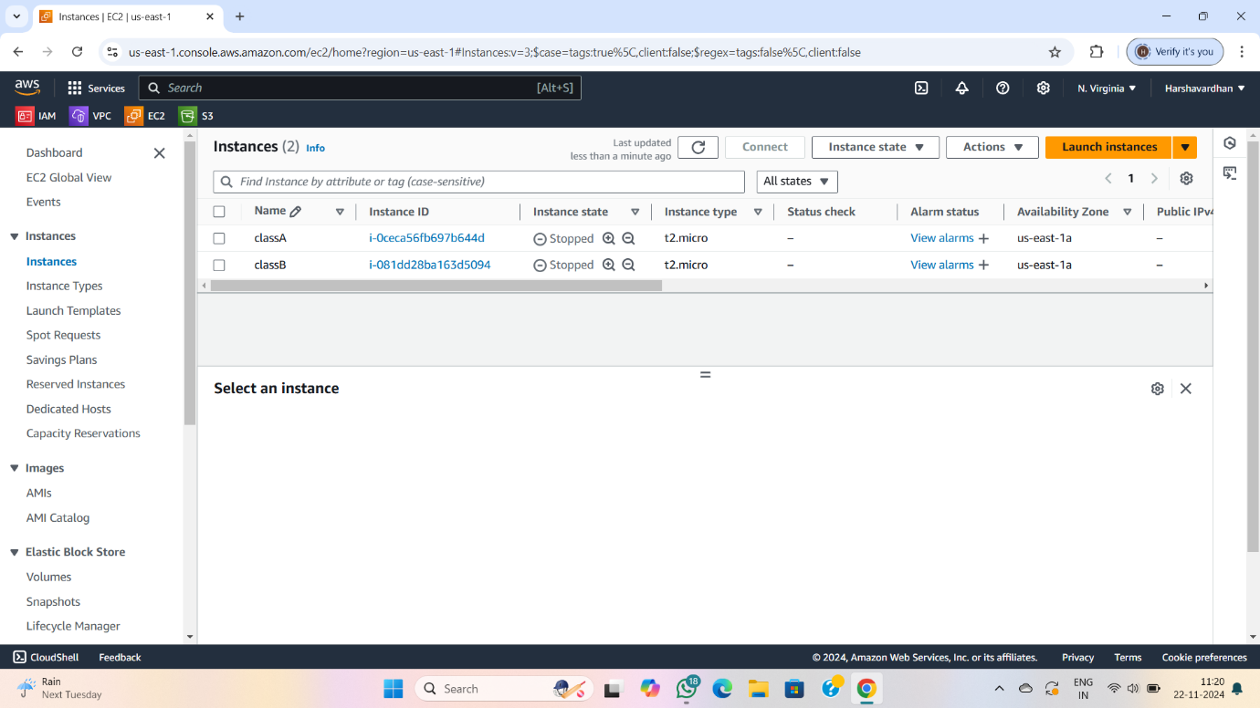

.CREATED SUCCESSFULLY AND RUNNING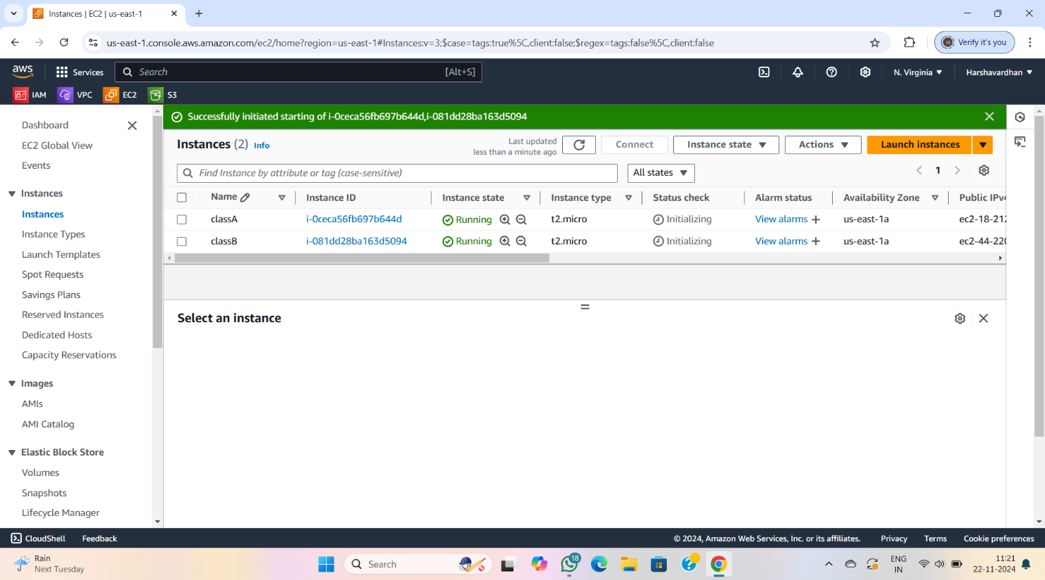

CREATING NEW KEY PAIRS

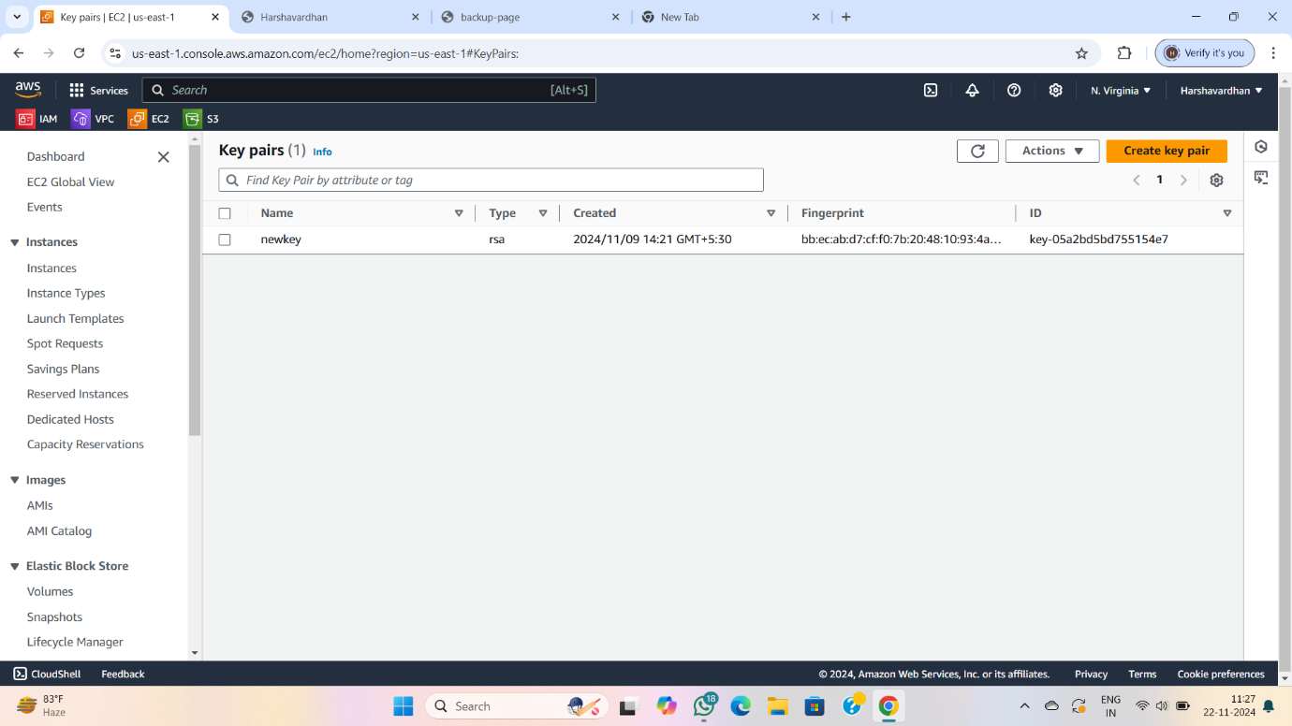

CREATING SECURITY GROUP

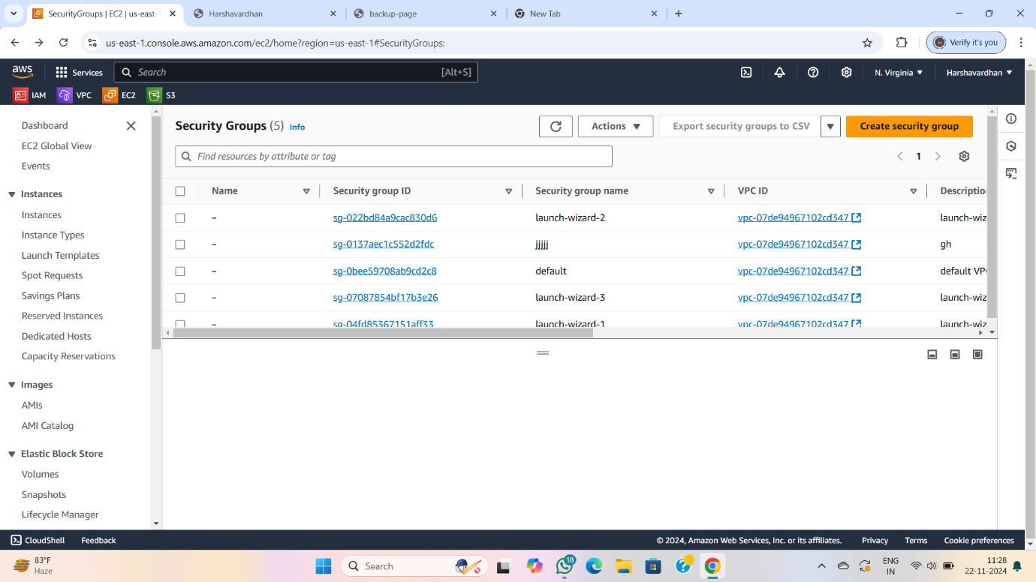

CREATING LOADBALANCER

NAME: ROOM(A) AND ROOM(B)

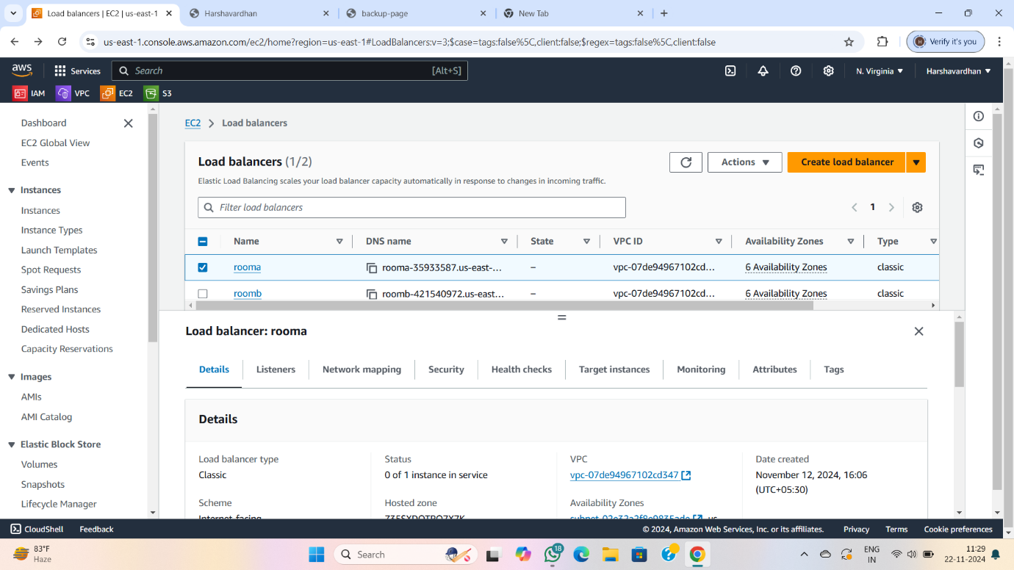 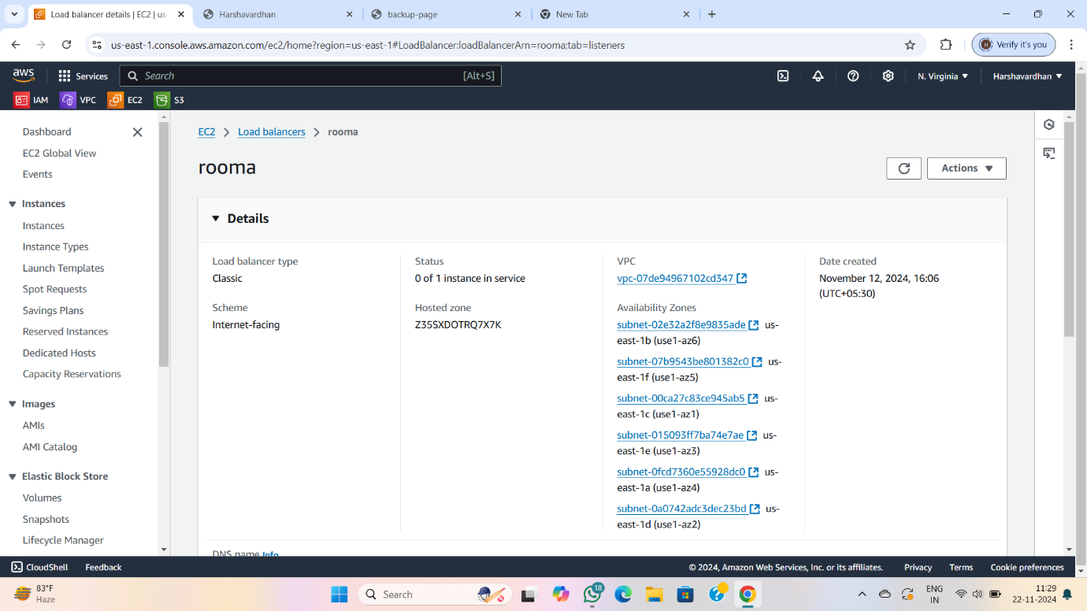

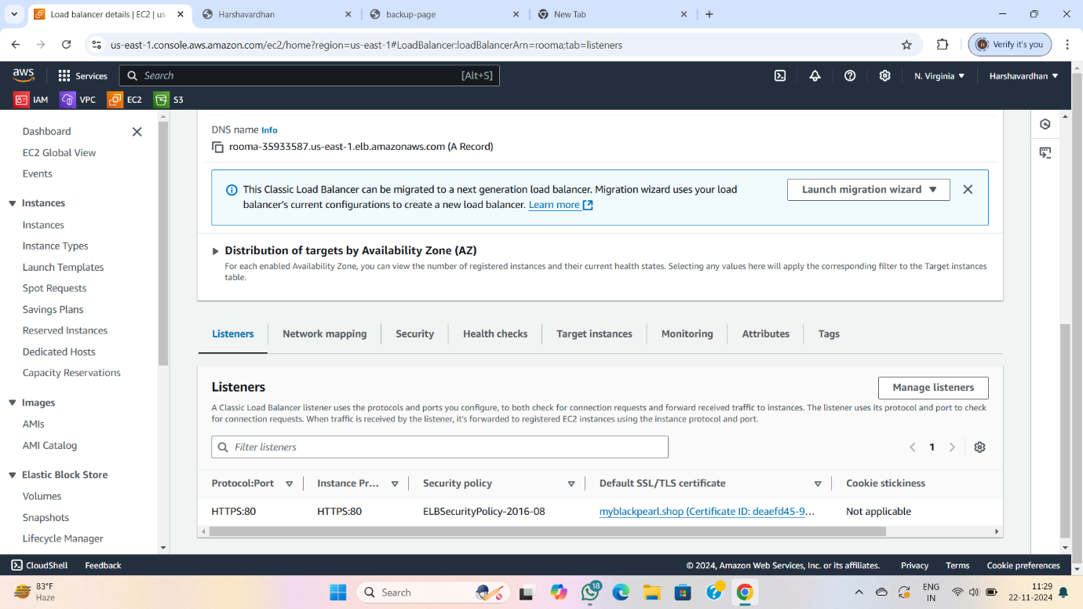

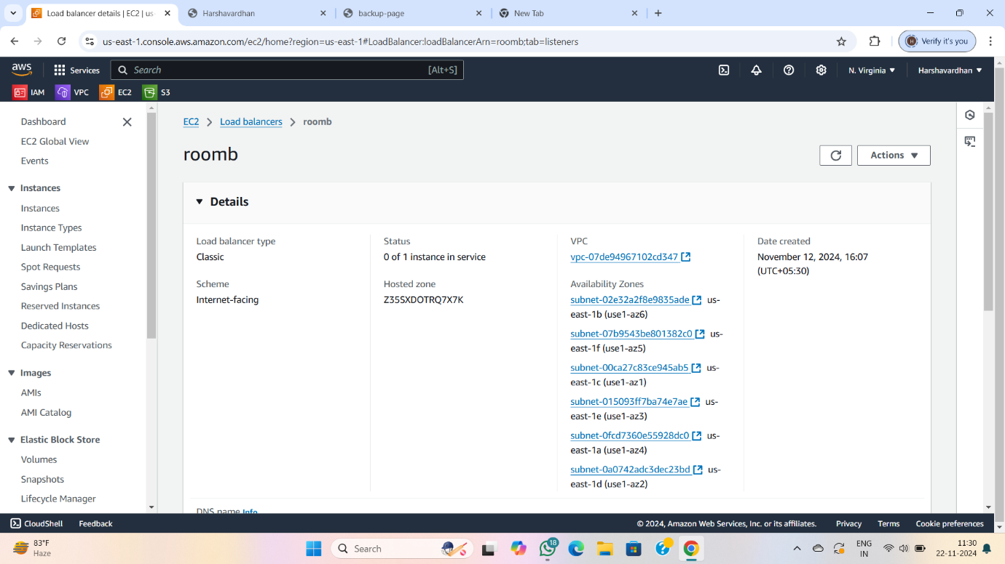

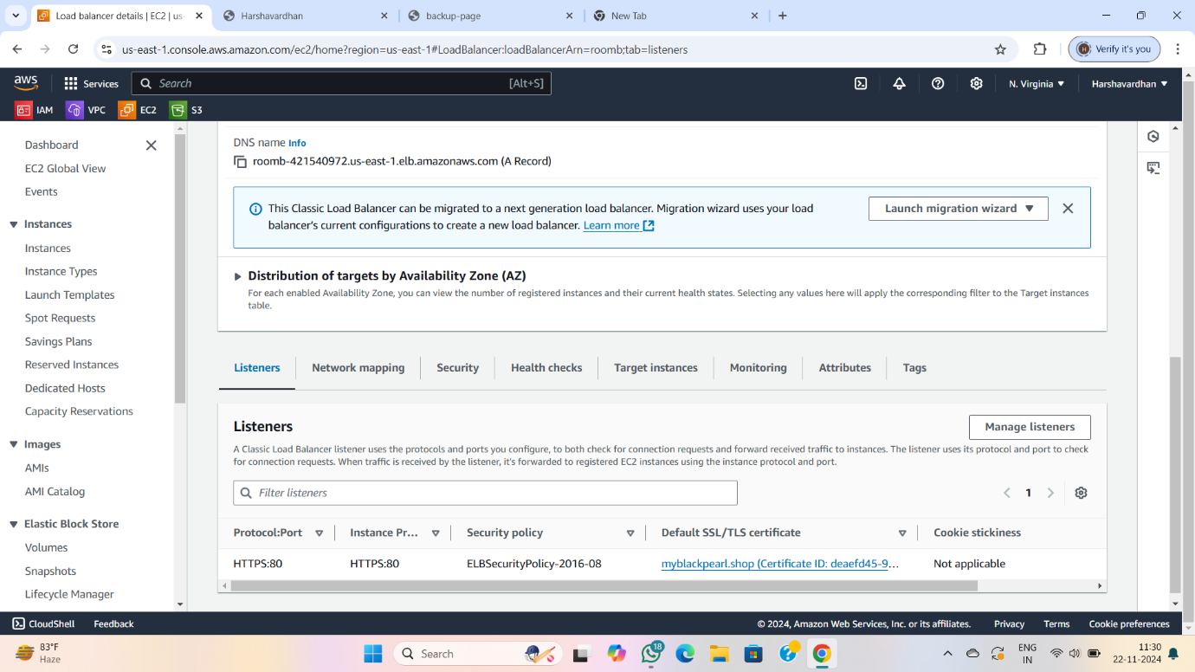

CREATED PROJECT FULL SERVICE AND CREATING TEXT

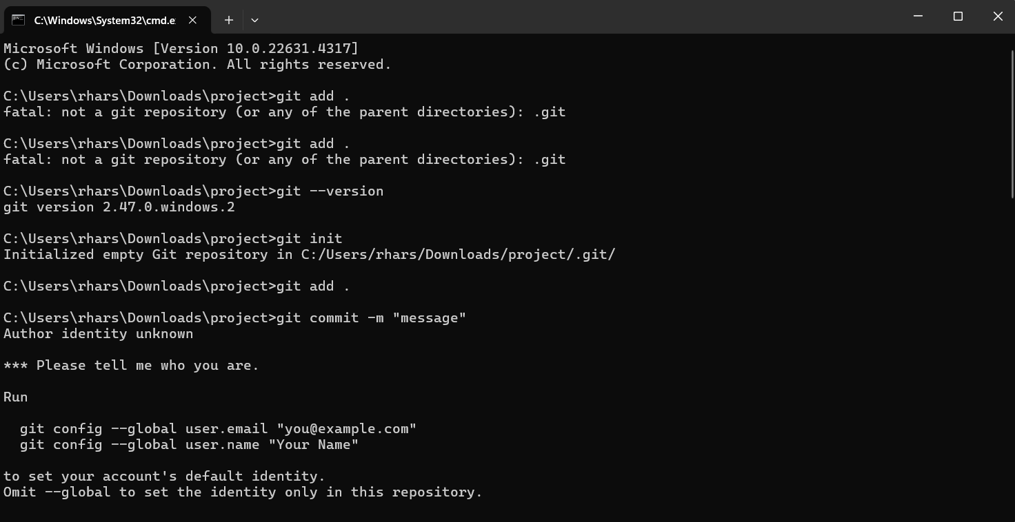

FINALLY PUTTING INTO GITHUB

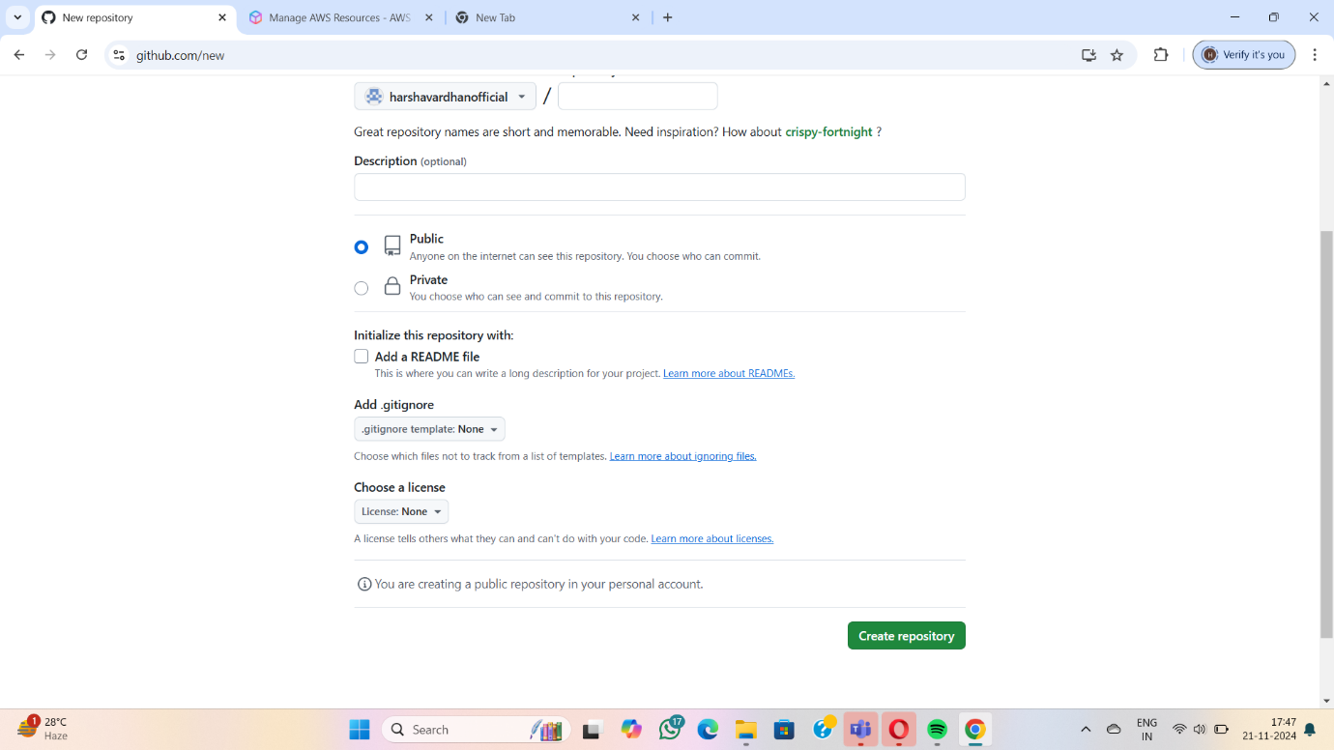

CHECKING MY WEBSITE

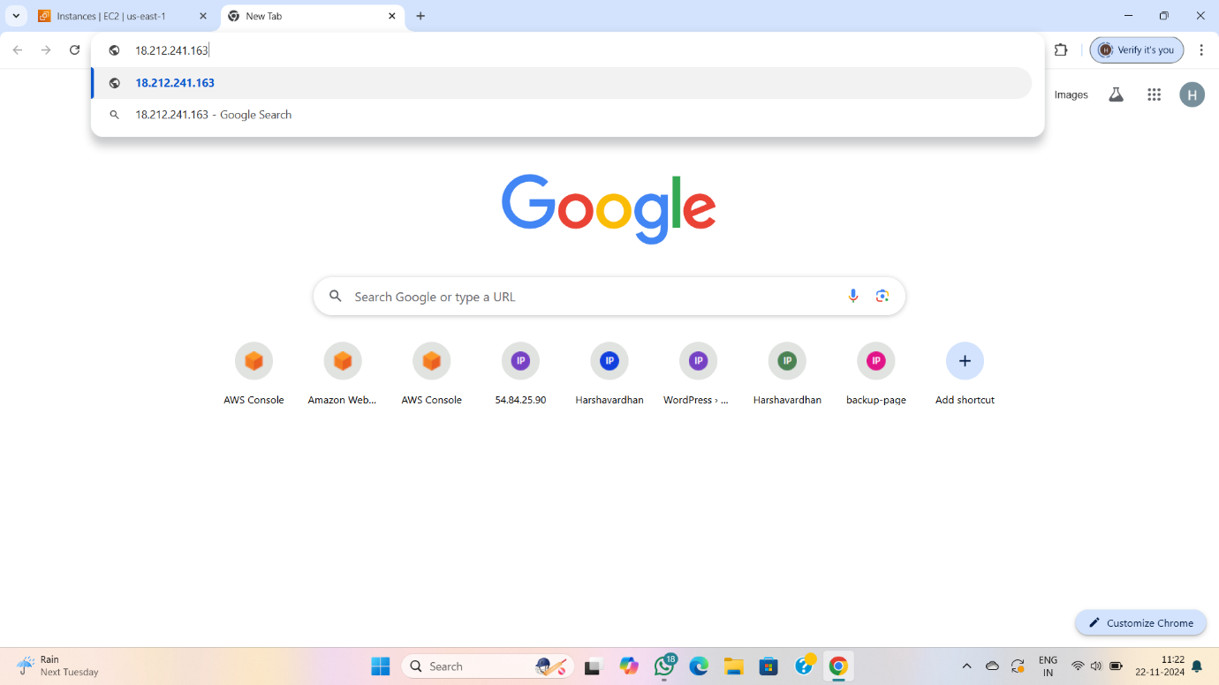

MY WEBSITE NAME:- HARSHAVARDHAN

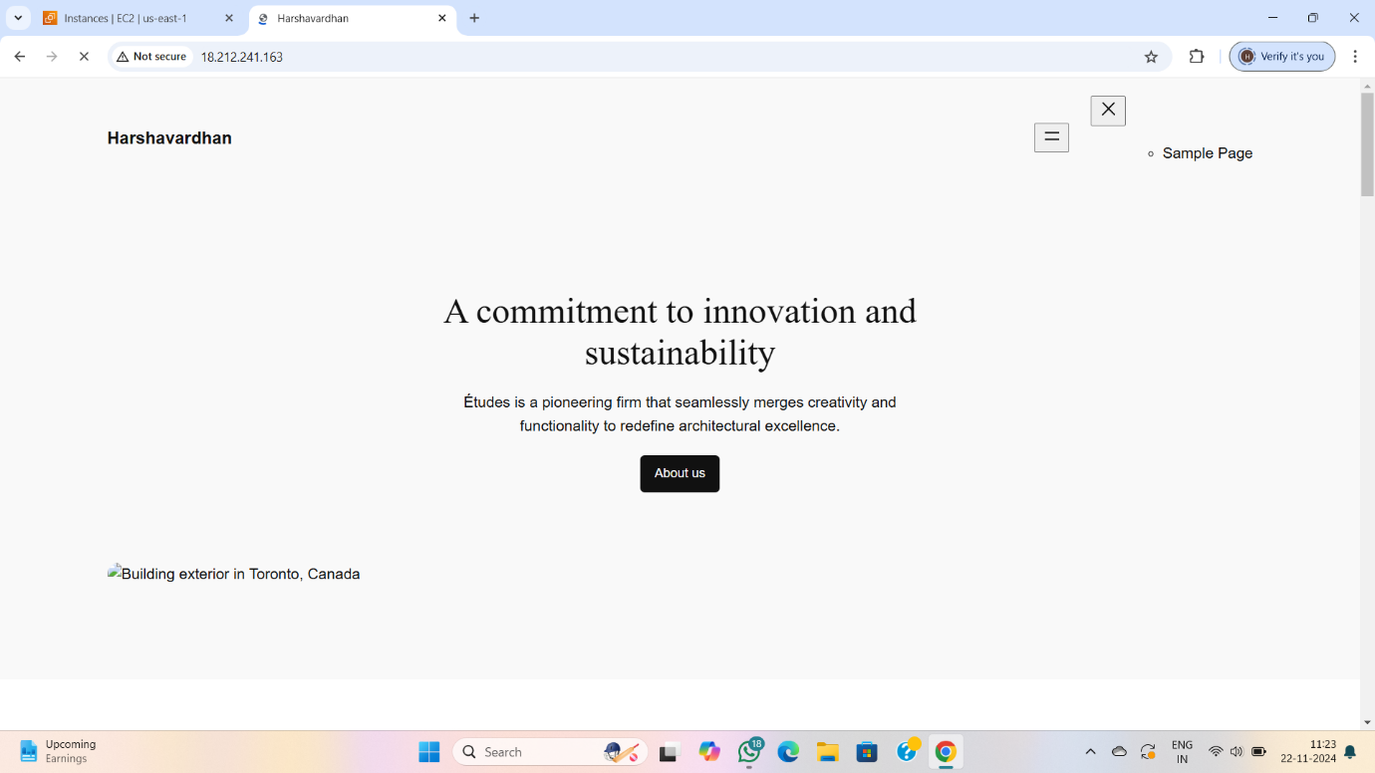SECOND PAGE IS BACKUP PAGE 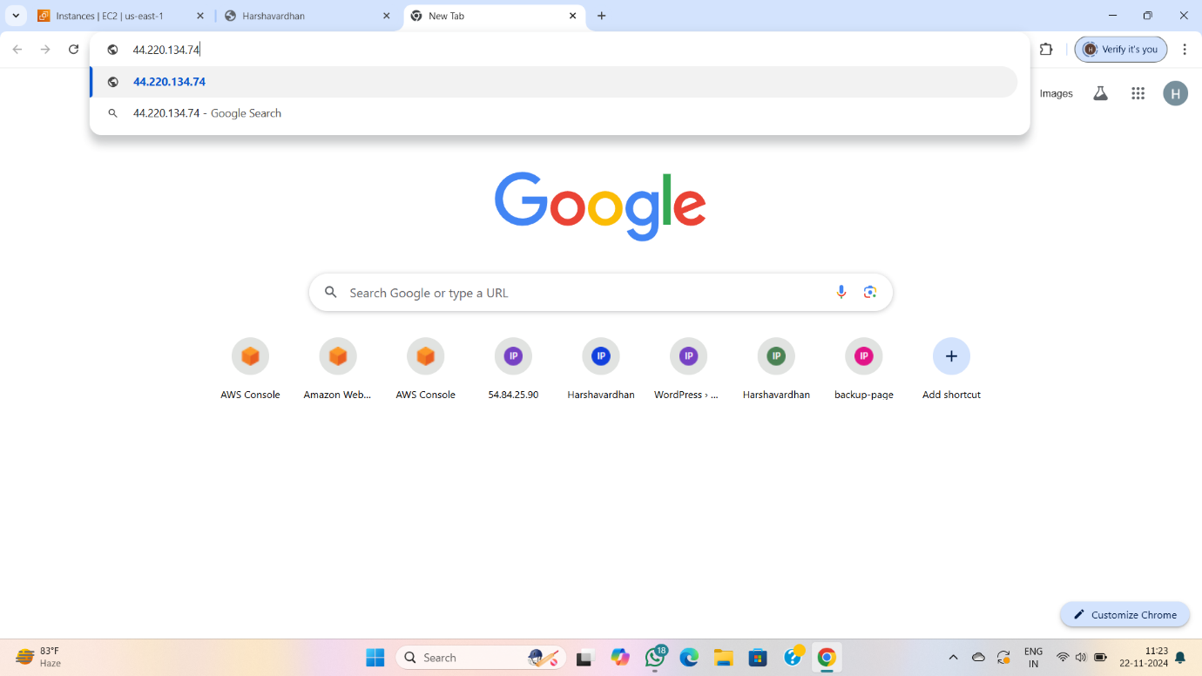

MY BACKUP PAGE

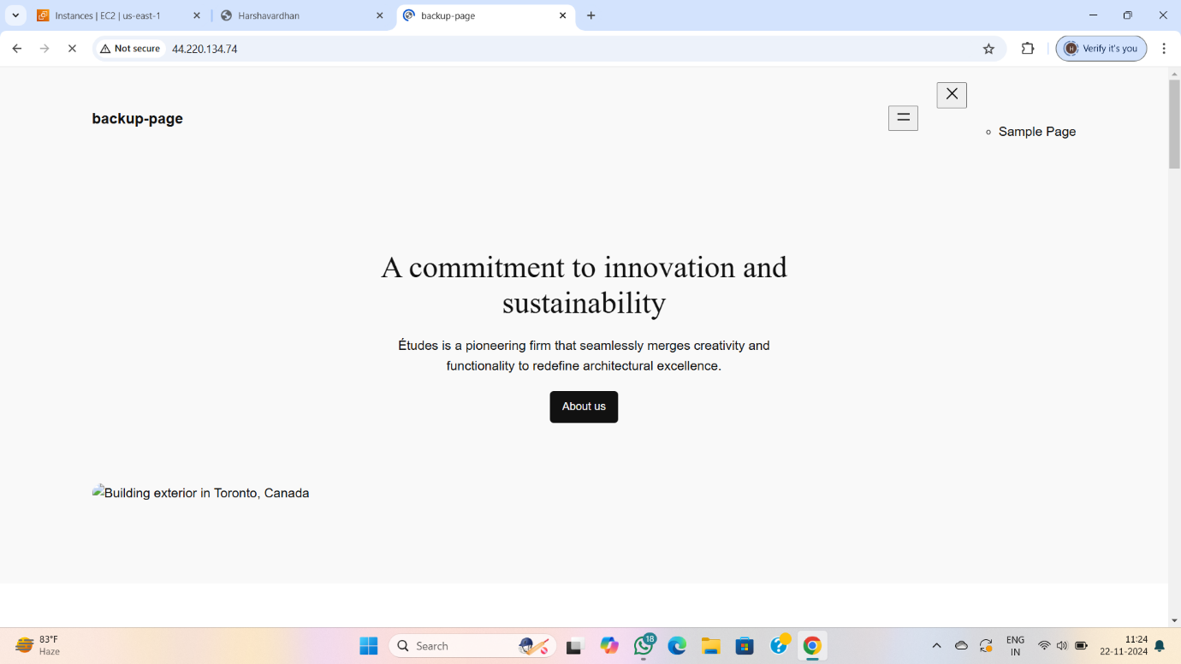

COMPELETED SUCCESSFULLY